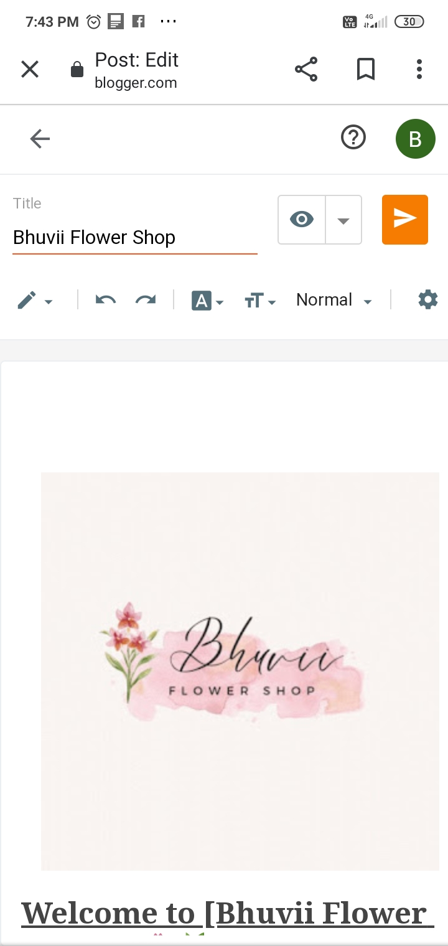**Digital Marketing Assignment -1**

|  |  |
| --- | --- |
| Student Name | Bhuvaneswari G |
| Student Register Number | 953720106004 |
| College Name | AAA College of Engineering and Technology |
| Naan Mudhalvan ID | E79A4099CE49E4CA1A4405CFF87251CC |

**Assignment:**

Create a blog or website using Blogpost and WordPress. Customize the theme design and post new article with 500 words.

**Solution:**

1.BlogPost

Link: https://www.blogger.com/blog/post/edit/5822850725482736879/8109225235445338585

2.WordPress:

Link:

https://wordpress.com/post/bhuviiflowershop.wordpress.com/4

